**PRACTICE REPORT**

**Subject: Web application**

**Lab 1: HTML/CSS**

*Instructor: Trần Vĩnh Khiêm*

*Report date: 19/10/2023*

1. **GENERAL INFORMATION:**

Class: MSIS207.O12.CTTT.1

|  |  |  |  |
| --- | --- | --- | --- |
| **No** | **Name** | **Student ID** | **Email** |
| 1 | Nguyễn Văn Trường Khoa | 20521472 | [20521472@gm.uit.edu.vn](mailto:20521472@gm.uit.edu.vn) |
| 2 |  |  |  |

## DETAILED REPORT

**Link Github contain code:**

<https://github.com/Nguyen-Van-Truong-Khoa/MSIS207.O12.CTTT.1>

**Exercise 1.**

1. **Basic, list**

|  |  |
| --- | --- |
|  |  |

**Image 1**. First code execute in browser of basic, list concept.

|  |  |
| --- | --- |
|  |  |

**Image 2**. Second code execute in browser of basic, list concept.

|  |  |
| --- | --- |
|  |  |

**Image 3**. Third code execute in browser of basic, list concept.

1. **Table**

|  |  |
| --- | --- |
|  |  |

**Image 4**. Code execute in browser of table concept.

1. **Form**

|  |
| --- |
|  |
|  |

**Image 5**. Code execute in browser of form concept.

**Exercise 2.**

Code:

|  |
| --- |
| <!DOCTYPE HTML PUBLIC "-//IETF//DTD HTML 2.0//EN">  <HTML>  <HEAD>  <TITLE>Nguyễn Văn Trường Khoa</TITLE>  <link REL="SHORTCUT ICON" HREF="images/cormen-tiny.jpg">  <style>      img {          overflow-clip-margin: content-box;          overflow: clip;      }  </style>  </HEAD>  <BODY TEXT="#000068" LINK="#060FDF" VLINK="#060FDF" ALINK="#DC24C5" BGCOLOR="#FFFFFF">  <!-- <TABLE CELLPADDING="10" CELLSPACING="0" WIDTH="475"> -->  <TABLE CELLPADDING="10" CELLSPACING="0">  <TR VALIGN=TOP>  <TD ALIGN=LEFT VALIGN=TOP WIDTH=151>  <IMG SRC="../Public/kedi1.png" height="220px" width="190px"><P>  </TD>  <TD ALIGN=LEFT VALIGN=TOP>  <H2>Nguyễn Văn Trường Khoa<br>  College Student, Information System major<br>  University of Information Technology, Ho Chi Minh City<br>  </H2>  <h3>  I was a student who was tormented by the many assignments my teacher assigned  </h3>  <!-- <p><strong>Update June 2022: I am a Democratic candidate for the New -->  <!-- Hampshire House of Representatives, running in Lebanon Ward 3 (Grafton -->  <!-- County District 15).<br> -->  <!-- <a href="https://cormenfornh.com">Campaign website</a> -->  <!-- </strong> </p> -->  <p>  Student, <A HREF="https://www.uit.edu.vn/">University of Information Technology</A>, Ungraduate.<P>  <DD>  <B>  <IMG SRC="https://www.cs.dartmouth.edu/~thc/images/yellowsq.gif" ALT="*" WIDTH=9 HEIGHT=9 ALIGN=center>    <A HREf="papers.html">Papers</A><BR>  <IMG SRC="https://www.cs.dartmouth.edu/~thc/images/yellowsq.gif" ALT="*" WIDTH=9 HEIGHT=9 ALIGN=center>       <A HREf="http://www.cs.dartmouth.edu/FG/">FG</A>       <!-- <a href="http://www.cs.dartmouth.edu/FG/"><IMG SRC="new.gif" ALT="*" ALIGN=center border=0></a> --><br>  <IMG SRC="https://www.cs.dartmouth.edu/~thc/images/yellowsq.gif" ALT="*" WIDTH=9 HEIGHT=9       ALIGN=center>     <A HREf="software.html">Other software</A><BR>  <IMG SRC="https://www.cs.dartmouth.edu/~thc/images/yellowsq.gif" ALT="*" WIDTH=9 HEIGHT=9 ALIGN=CENTER>       <a href="cormen-vita.pdf">Vita</a>  </B>  </DL>  </TD>  </TR>  </TABLE>  <TR VALIGN=TOP>  <TD COLSPAN="2">  <hr>  <h3>Contact Information</h3>  Email:<br>  <a href="mailto:20521472@gm.uit.edu.vn">20521472@gm.uit.edu.vn</a>  <p>  V.N. Mail:<br>  The house of idiots<br>  766 Võ Văn Kiệt street<br>  District 5<br>  Ho CHi Minh City  <p>  <P><HR SIZE=4>  <H4>  <IMG ALIGN="MIDDLE" SRC="https://www.cs.dartmouth.edu/~thc/images/Dtree.gif" WIDTH=34 HEIGHT=39>  <A HREF="/">Back to Dartmouth Computer Science Home Page</A>  </H4>  </TD>  </TR>  <hr>  <address><a href="./exercise2.html">Nguyễn Văn Trường Khoa &lt;20521472@gm.uit.edu.vn&gt;</a></address>  </body> </html>  </BODY>  </HTML> |

Demo:

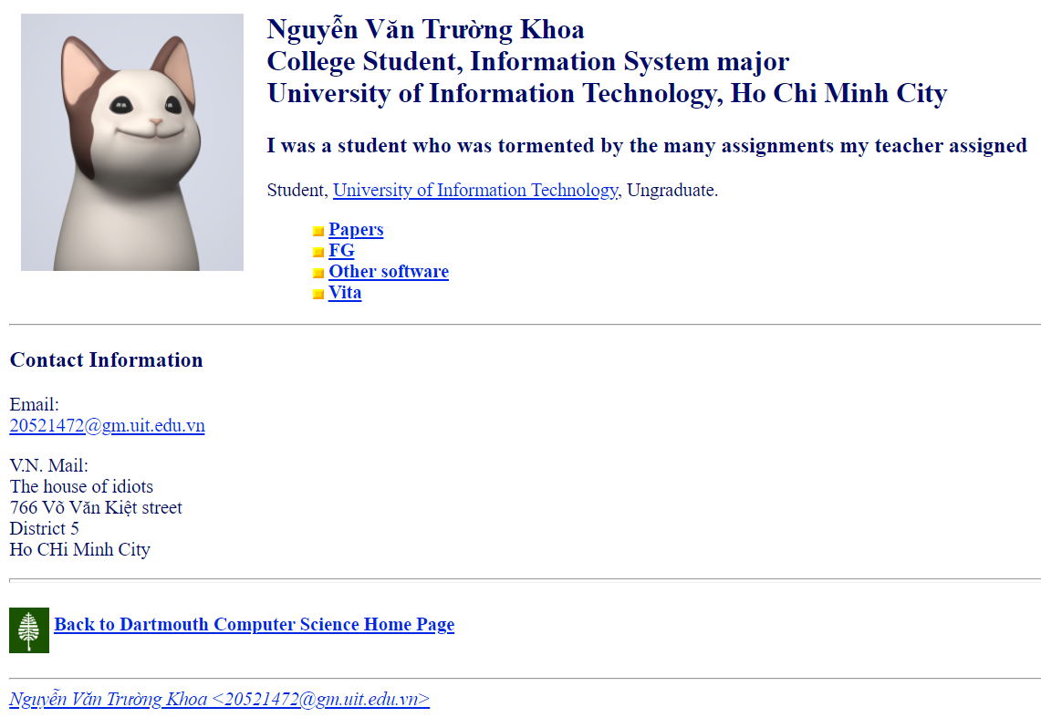

**Image 6**. Code execute in browser of exercise 2.

**Exercise 3.**

Code :

Demo:

**Homework 1.**

**Homework 2.**

**Homework 3.**